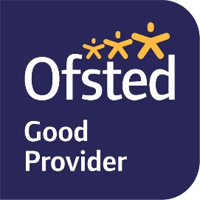
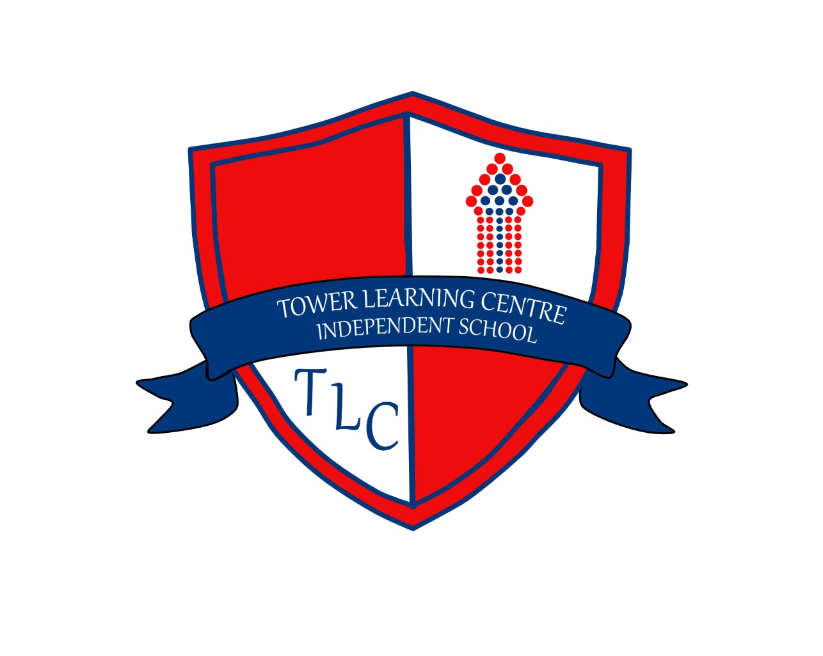

PRIVACY NOTICE

PUPILS AGE 13+

WHO PROCESSES YOUR INFORMATION?
Data Protections laws ensure your personal data is kept safe. This is information that can identify you, like your address, date of birth and phone number. The school and other people collect and use your personal data for different reasons, and Data Protection laws tells them exactly what they are allowed and not allowed to do with it.
We collect personal data about our pupils, like you, and Data Protection laws require us to tell you how we will collect this information, how we will record it and how we will use it. We are telling you this in this Privacy Notice. These laws allow pupils aged 13 and over, as long as they understand the issues clearly, to be involved in the decisions on their personal data.
In this Privacy Notice, you will see different names or terms that you may not be familiar with, such as:
Data Controller: Tower Learning Centre Independent School, who oversee the management, is in charge of the information collected. They decide how and for what reasons information can be collected, processed and shared.
Data Processor: They process the information for different uses and have to follow Data Protection laws. Data Protection Officer: This person makes sure we use your information correctly under the Data Protection law.
If you have any questions regarding anything in this privacy notice you can contact:

Proprietor
Tower Learning Centre
316 Church Street
Blackpool
FY13QE
or email – kate@tower-learning.co.uk

If you would like to talk to anyone about this in the school, please ask your Teacher to arrange for you to speak to your schools Data Protection Lead.

WHY DO WE NEED YOUR INFORMATION?
We will only collect your information when we need it to help us do our job or to follow the law. When we have collected it, we use it to:
- support your learning
- monitor and report on your progress
- provide appropriate pastoral care
- keep you safe
- assess the quality of our services
- comply with the law regarding data sharing

INFORMATION THAT WE COLLECT, PROCESS, HOLD AND SHARE INCLUDES:
- personal information – this is things like your name and address;
- characteristics and special categories of data – this means information about you, like where you are from and what language you speak;
- free school meal eligibility – so you can be provided with what you are entitled to;
- attendance information – how many times you have not been able to come to school and why;
- assessment information – we collect your test and exam results;
- behavioural information – the number of times you may have been excluded and why;
- relevant medical information – any illnesses or special conditions that you may have so we can keep you safe;
- information on Special Educational Needs and Disability (SEND) – information that helps us to teach you;
- CCTV images for safety and security on school premises;
- Photographs and video recordings – to place on display boards or our website; before we take any we will ask you or your parents for permission.

THE LEGAL DETAIL
Under Data Protection laws (GDPR Articles 6 and Article 9) we are allowed to process your personal data as long as we follow the rules on how to do it. Your school has a Record of Processing that details the law and the rules that are being followed to enable your personal information to be processed.
We process your information in order to deliver education to you. A lot of the information we hold about you is mandatory, which means by law we have to do it, otherwise it would be impossible for us to do our job.

COLLECTING YOUR INFORMATION
If it is mandatory then you have no option but for us to have this information, and some of your information we may have to get from other places if we are required to do so. Some special category information (for example racial or ethnic origin and religion) we will not use unless you are specifically aware of it.
When we ask you for information that you do not have to give us, we will ask you for permission and let you know why we want it and what we will do with it. You then have the choice whether you wish to provide your permission.

HOW LONG WILL WE KEEP YOUR INFORMATION?
We will not keep your personal data forever, only for as long as we need it to help us do the thing that we needed it for. We have a policy that tells us how long to keep it and when and how we need to destroy it.

SHARING YOUR INFORMATION
We do not share your information with anyone without permission unless the law says we can or should. We share information with the following:
- The Local Council
- Department for Education (DfE)
- Education Skills Funding Agency
- Standards and Testing Agency
- Ofsted
- Police
- Social Services
- Educational Psychology Department
- Children & Adolescent Mental Health Services (CAMHS)
- Children and Family Court Advisory Service (CAFCAS)
- Careers Advisory Service providers
- Peripatetic services
- Alternative education providers
- Other schools/academies (during pupil transfer)
- Sixth form colleges and other post-16 providers
- Examination Boards
- Print Management Software providers
- Management Information Systems
- Text and Email communication systems
- IT Contractors
- Providers of online learning resources
- Financial management software

One of those we have shown as having to share information with is the Department for Education (DfE) who are in charge of all schools. The DfE ask us for information like how many pupils we have, how well they attend and how well they do in their exams. They store some of their information in the National Pupil Database, and then share some of it with people looking to help schools and pupils. The DfE make sure the database is safe and that information is only shared with people who will use it safely.
When you reach the age of 13, we have to pass certain information to the local Council and to Youth Services providers. At age 16 we may also pass on some of your information to local colleges, other training providers and careers services. This will enable them to provide you with training and future career advice. Your parents or carers can ask that we only share your name, address and date of birth by contacting the school. At age 16 you can decide what information you want to share yourself.

WHAT ARE YOUR RIGHTS?
You have specific rights in relation to the processing of your personal data. You have a legal right to:
  - ask to see the information we hold;
  - ask us to change information you think is wrong;
  - ask us to remove information when it is not needed anymore;
  - ask us to only use information in certain ways;
  - tell us that you do not want your information to be processed.
You have to contact the Data Protection Officer (on the details previously given) in order to do any of these. The school also has a Subject Access Request Form that you can get from your school office to make sure you include all the information needed. The school will consider all requests in line with the law.
If the information we are collecting is information that you can chose not to give, you can tell us to stop collecting it at any time. This will not affect any information that you gave us before you change your mind on the permission.
If you are worried about how we get or use your information, you can see your Teacher who will arrange for you to speak to your school’s Data Protection Lead. You can also contact the Data Protection Officer (on the details previously given). If you want to speak to somebody not connected with your school you can contact the Information Commissioner’s Office at https://ico.org.uk/concerns The Information Commissioner’s Office oversee the Data Protection laws for the United Kingdom.
You can see the personal information the DfE hold about you by making a “subject access request” to them. Further information on how to do this can be found within the DfE’s personal information charter, which is available at the following web address: https://www.gov.uk/government/organisations/department-for- education/about/personal-information-charter

You may also contact the DfE with any questions you have regarding how they use your personal information, by visiting: https://www.gov.uk/contact-dfe

